**Nimham Mountain Music Festival**

**May 11, 2013 2-10pm**

**Vendor Form**

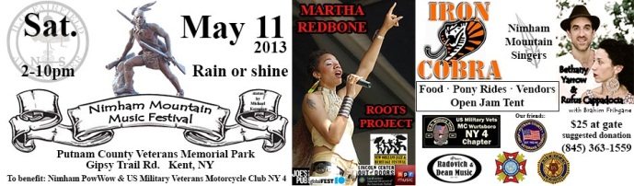

Please fill out and e-mail this form to [Office@HGFairfieldArts.org](mailto:Office@HGFairfieldArts.org).

Vendor fee is $75.

**Contact Name:** __________________________________________________

**Business Name:**_______________________________________________________

**Business website:** _________________________________________________

**E-Mail:** _________________________________________________

**Phone Number:** __________________________________________

**Are you a food vendor?**  □ Yes □ No

**If yes, what Health Department permits do you have?**

_____________________________________________________

**If no, what do you sell?** _____________________________________________________

**Checks can be made payable to:**  **H. G. Fairfield Arts**

**31 Sodom Road**

**Brewster, NY 10509**

Call (845) 363-1559 for more information or if you have any questions.