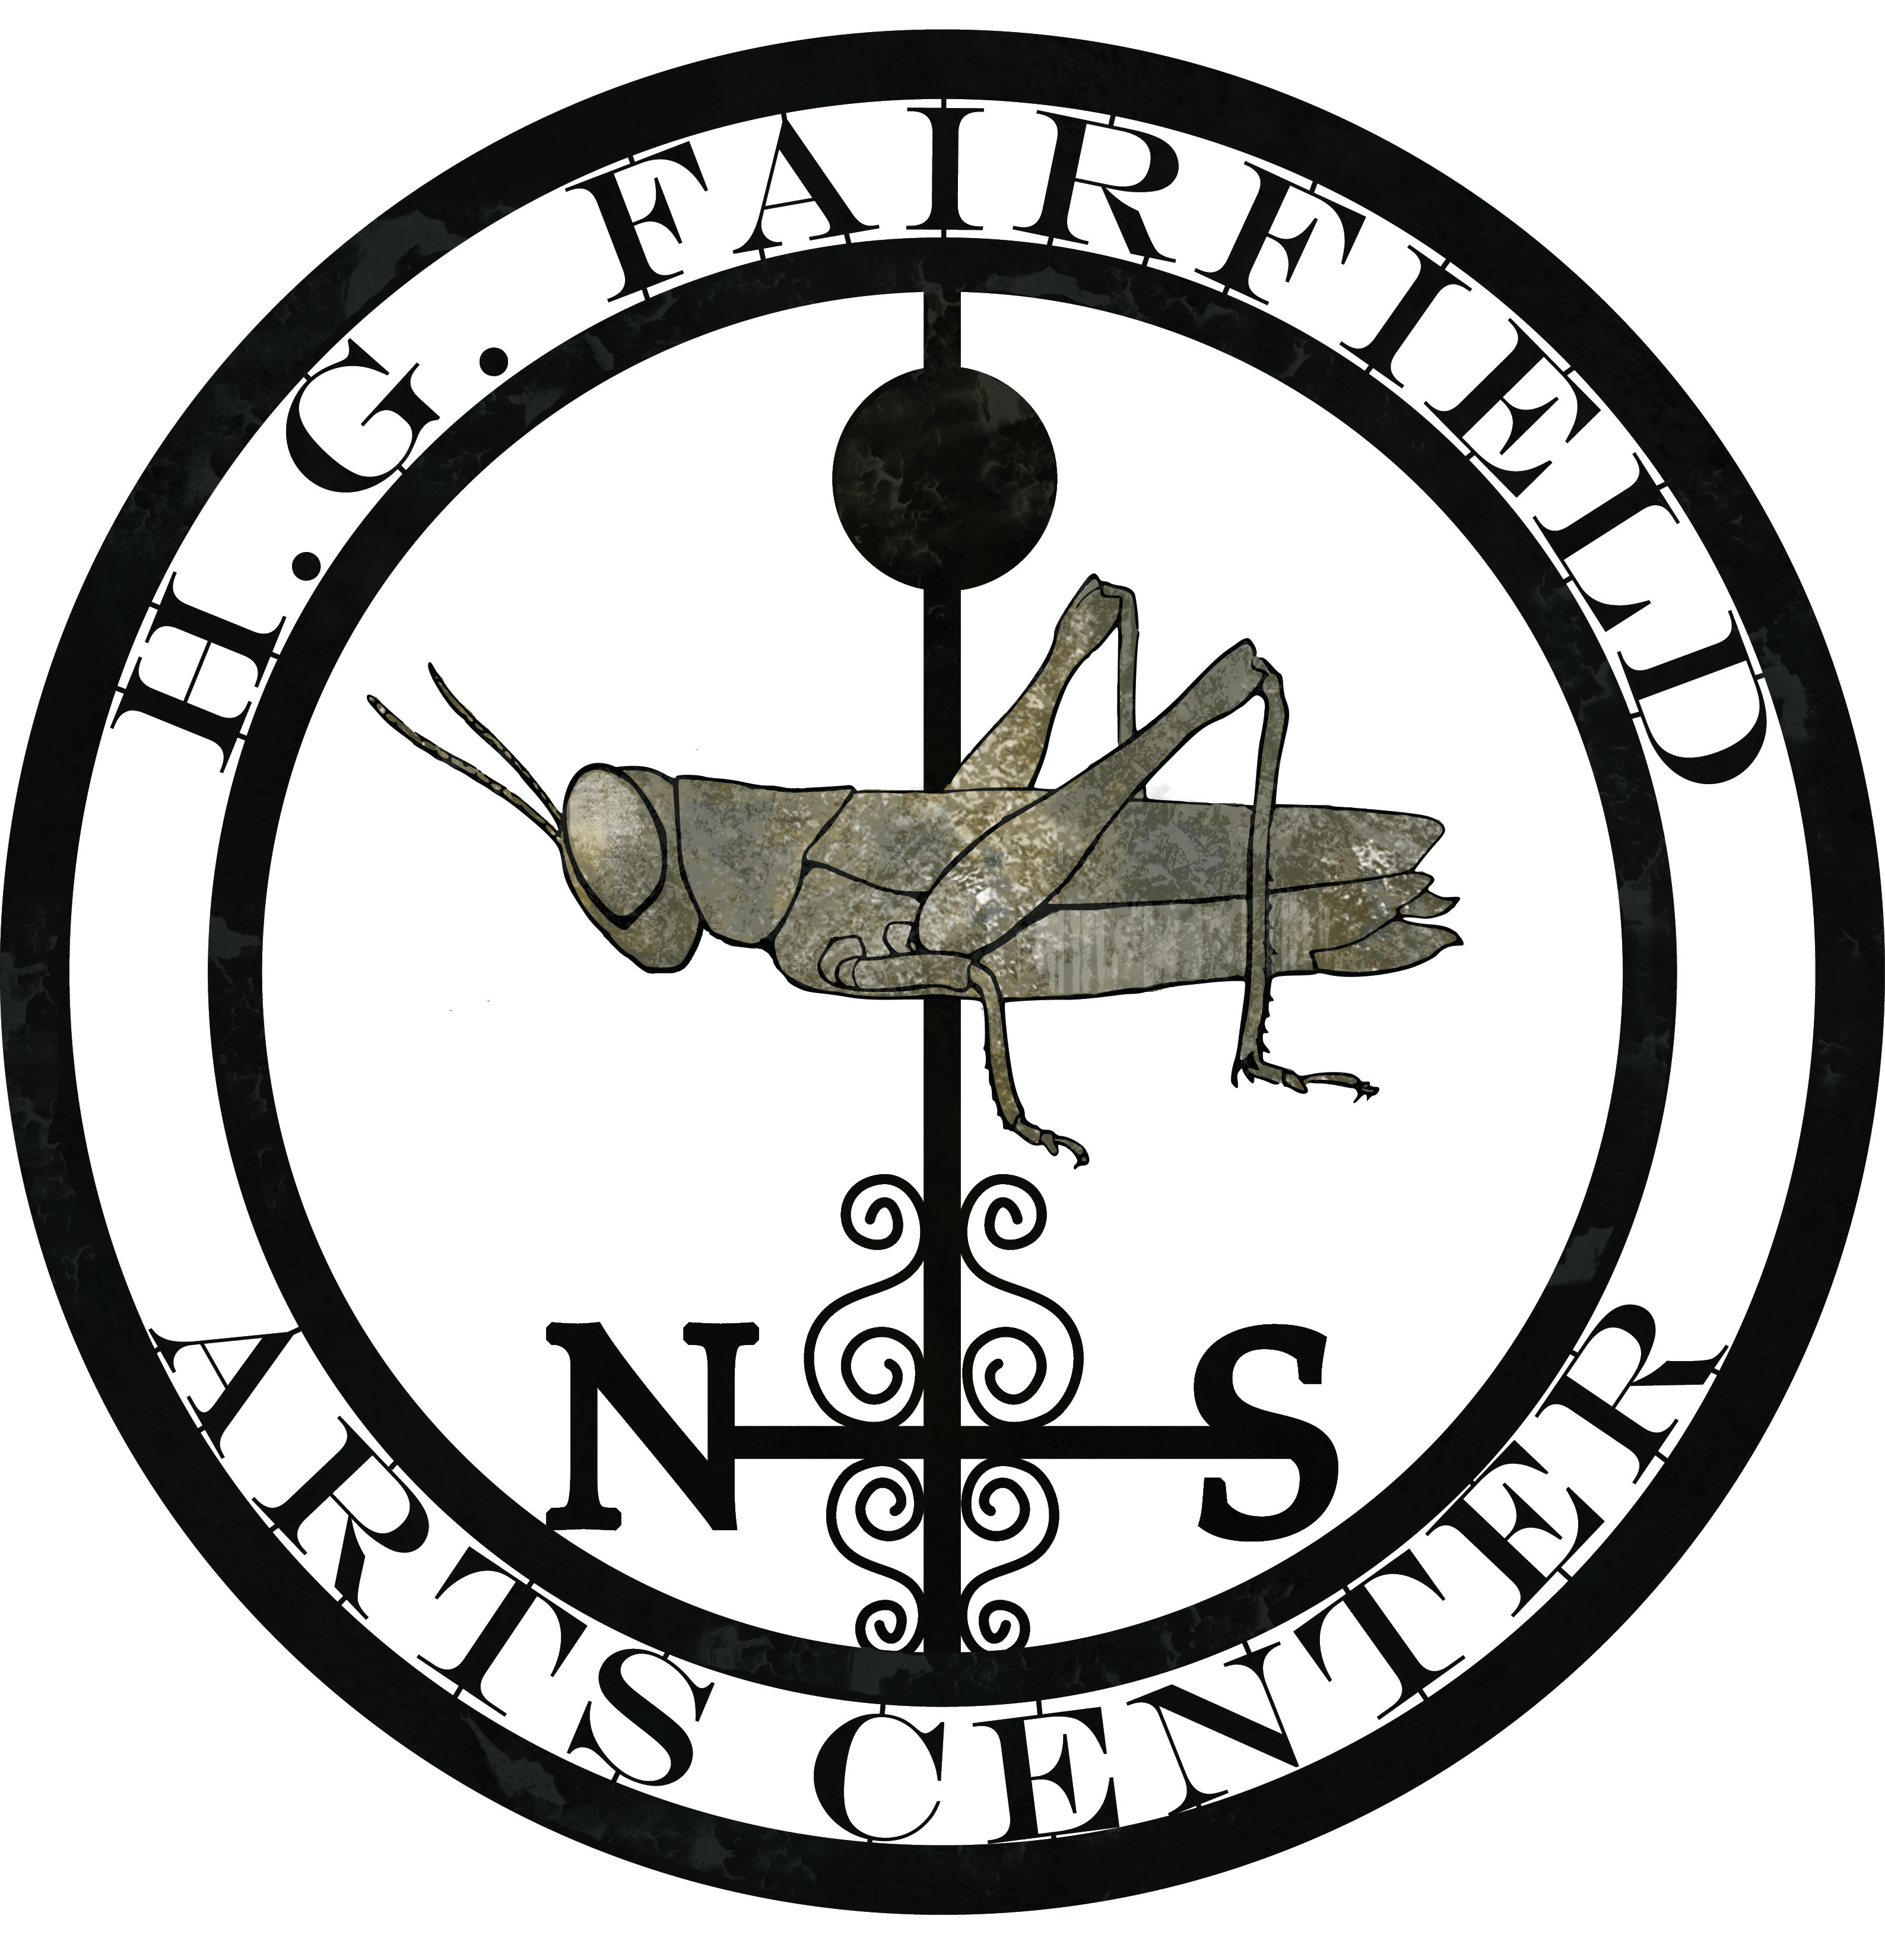
31 Sodom Road
Brewster, New York 10509
Phone: 845-363-1559
Fax: 845-279-2062
www.HGFairfieldArts.org
Exec@HGFairfieldArts.org
30 April 2013

Hello,

H. G. Fairfield Arts is a 501(c)3 organization with offices in Brewster, New York. Our motto is “See a need; fill it.” We use arts and culture to meet the needs of our communities, specializing in Art Without Walls and creating public events which accompany awareness and fundraising campaigns. We are particularly committed to veteran populations and have strong ties to local and national veteran communities.

We are entering our third year of working with national comedian and Navy veteran PJ Walsh, in our joint initiative “Courage Continues At Home III,” which brings attention and funds to the needs of veterans and their families. In 2004, PJ Walsh was performing in Iraq in a commandeered theater for 1,500-2,000 US troops when the theater came under fire. In our first year touring with him, PJ was telling this story at a WPDH Radiothon to benefit local veterans when another Navy veteran popped up in the live audience to tell his story of heading up security for that event in Iraq – he took out the source of the shelling.

H. G. Fairfield Arts is now making a documentary film about this extraordinary turn of chance encounters between PJ Walsh and USMVMC NY 4 President Bill “Bomber” Barber. The documentary dovetails with our “Courage Continues At Home III” campaign with national comedian & Navy veteran PJ Walsh, as we follow PJ Walsh & the USMVMC NY4 trek from Wurtsboro, NY to San Antonio, TX for the National Meeting of USMVMC Presidents. PJ Walsh will perform for the veterans in San Antonio and H. G. Fairfield Arts will be the only outside vendor bringing in information about ways for veterans and their families to cope with PTSD and other effects of war.

If you would like to assist us in helping our veterans and their families adjust to life after war, please consider supporting this project. We have three levels of sponsorship available: Gold, Silver, and Bronze. Please see our sponsorship form for more information on each level’s benefits.

This film is a fantastic opportunity to help encourage healing of veterans and their families through humor, humanity, and heart. Humor and PJ Walsh have been the catalyst for helping Bomber rediscover his lifeline, and now he comes forward to discuss the personal challenges of PTSD. This documentary will be a real life-changer for combat veterans like Bomber, and it will also facilitate a national discourse on helping our veterans and communities move forward.

Thank you very much for your time and consideration.

Sincerely,

Kim Blacklock
President
H. G. Fairfield Arts Center for the Environment, Inc.

